**Week 10 - In Class Lab**

**Problem 1: Removing Duplicates**

You have a list of numbers, num_list, with duplicate elements (You don’t have to get the numbers from the user). Write Python code to convert the list into a set to remove duplicates and then convert it back to a list. Display the resulting list with duplicate elements removed.

**Paste the Screenshot of your source code below:**

from random import randint

num_list = [randint(-15, 15) for _ in range(12)]

print(f"Before removing duplication: {num_list}")

num_list = list(set(num_list))

print(f"After removing duplication: {num_list}")

**Paste the Screenshot of your output below:**

**whitewolfzhang@White**:**~/Library/CloudStorage/OneDrive-Personal/Documents/Acadamic/OCC/F2024/CS_131/Codes/Week 10 Lab**$ python3 p1.py

Before removing duplication: [2, -1, 15, -5, -1, 14, -6, -2, 10, 1, 5, 9]

After removing duplication: [1, 2, 5, 9, 10, 14, 15, -2, -6, -5, -1]

**Problem 2: Unique Elements**

Write a Python program that takes two lists of integers, list1 and list2, and performs the following set operations:

* Find and display the elements that are common in both list1 and list2.
* Find and display the elements that are unique to list1 (not in list2).
* Find and display the elements that are unique to list2 (not in list1).

The program should do the following:

* Prompt the user to enter a list of integers separated by spaces for list1.
* Prompt the user to enter a list of integers separated by spaces for list2.
* Split the user input and create sets from list1 and list2.
* Perform the set operations mentioned above.
* Display the results.

How to get input in a list:

input_list1 = input("Enter elements for list1 (separated by spaces): ").split()

**Example:**

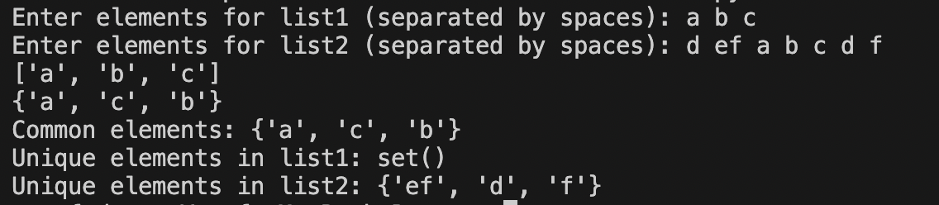

Paste the Screenshot of your source code below:

s1 = set(input("Enter elements for list1 (separated by spaces): ").split())

s2 = set(input("Enter elements for list2 (separated by spaces): ").split())

print(f"Common elements: {s1 & s2}")

print(f"Unique elements in list1: {s1 - (s1 & s2)}")

print(f"Unique elements in list1: {s2 - (s2 & s1)}")

Paste the Screenshot of your output below:

**whitewolfzhang@White**:**~/Library/CloudStorage/OneDrive-Personal/Documents/Acadamic/OCC/F2024/CS_131/Codes/Week 10 Lab**$ python3 p2.py

Enter elements for list1 (separated by spaces): a b c

Enter elements for list2 (separated by spaces): d ef a b c d f

Common elements: {'c', 'a', 'b'}

Unique elements in list1: set()

Unique elements in list1: {'f', 'd', 'ef'}